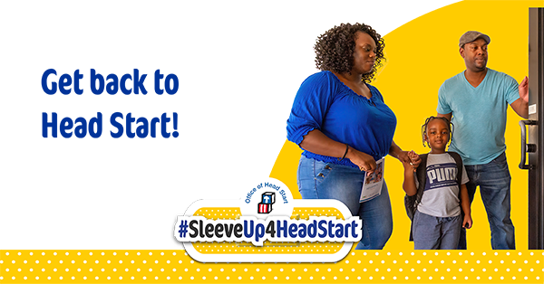

NOTICE TO ALL CURRENT STAFF AND APPLICANTS

Here at the SNMCAC Head Start Program, we care about protecting the health and well-being of our
staff, children, families and clients.

In accordance with federal regulations, as of January 2022, SNMCAC Head Start will uphold the mandatory vaccination decree for all employees as a condition of employment. If you apply for and are offered employment, you will be required to provide *proof of full vaccination against the COVID-19 virus.

*We will consider valid requests for an exemption from this requirement, but cannot guarantee that we will be able to accommodate having unvaccinated employees in our employ.

